CSCI/CMPE 4301 DIP Guide
Open book and notes
Jupytor notebook
Exam-03 Name:
You have 3 questions, all of which to be implemented in a notebook.
Make sure to know how to start and save a notebook. Loss of file or inability to read it is your responsibility.

Show all work for full credit.
- Given two histograms of color, calculate the minimum intersection metric given by the following formula (metric). Use NumPy to create two test histograms of size 10, populate them with random integer data from 10-100, then calculate the distance.

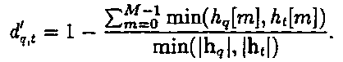

- Find an image of a cigarette box on the internet, create and show the HOG features for that image using skimage packages.
You can use “from skimage import feature” to calculate the hog feature.
  - Your notebook will read the image, show the original image, calculate the hog, then show the hog image. The output should look similar to the following image.

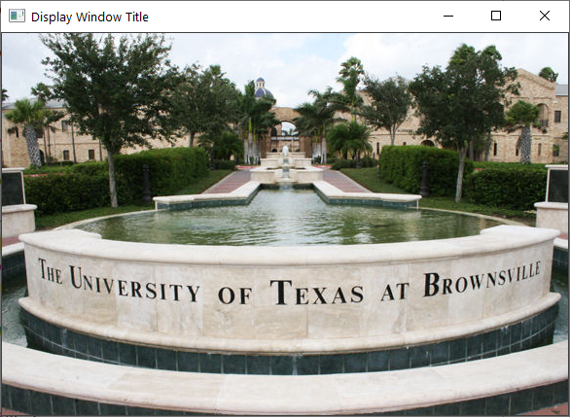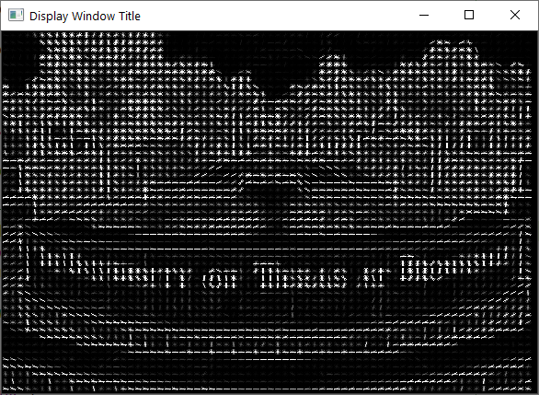

- Capture live video and show an object with red in it (a red pen, even your hand and skin will do). Use the HSV color space to highlight the area with redness (using a bit-wise mask), if present.
  - Check the color as feature slides, and particularly the python code that detects the blue caps. You should understand the code there, then adjust it to detect the blood.

#live video capture skeleton code
import cv2 as cv2
import numpy as np
cap = cv2.VideoCapture(0)
while(True):
code, frame = cap.read()

# Convert BGR to HSV

cv2.imshow('frame',frame)
if cv2.waitKey(2) & 0xFF == ord('q'):
break
cap.release()
cv2.destroyAllWindows()

